Audit program MS SQL (2008R2, 2012, 2014)

Section | year | Auditor - date/sign | Archive

Quality assurance - date/sign

Case | process

Content
0 General conditions 2
1 Policies, system documentation, and best practices 2
2 Overview of databases 4
3 User access to database 4
3.1 Method for access 4
3.2 Database management (server) level access 5
3.3 Database level access 8
3.4 Other access parameters 10
4 Passwords 14
5 Surface area reduction 17
6 Audit and logging 28
7 Version, updates and patches 31
8 Total conclusion 32
Appendix 1: Collection of data 33
Appendix 2: Running the script 35

General conditions

This program is based on "CIS_Microsoft_SQL_Server_2014_Benchmark_v1.2.0.pdf" from https://www.cisecurity.org/

Policies, system documentation, and best practices

- Is there a policy for MS SQL databases?
(Policies are management's security requirements, etc.)
Tips to the Auditor: There should be one or more policies that sets requirements for the security level.

Risk: Missing policies can result in a security level (setup in the database) that's not according to management's intentions or desires.
Appropriate audit evidence: Policy.
ISO/IEC 27002:2013: Chapter 5.
Regulations for Norwegian state enterprises : clause 2.4 internal control.
Answer:
- Facts...........
- The auditor's review of gathered documentation and facts..............
- Seems ok or should be reported

Audit Evidence:

- Is there system documentation for the MS SQL databases?
(The system documentation should show the design and layout.)
Tips to the Auditor: The System documentation must show the design and setup requirements.

Risk: Missing system documentation increases the chances of misconfiguration, and could lead to a system that is not set up in a secure way. The ability to make controlled changes will be reduced ass well. Audit evidence is the system documentation.
Appropriate audit evidence: System Documentation.
ISO/IEC 27002:2013: section 12.1.1?
Regulations for Norwegian state enterprises: clause 4.3.5 Documentation of the General System.
Answer:
- Facts...........
- The auditor's review of gathered documentation and facts..............
- Seems ok or should be reported

Audit Evidence:

- Are there procedures for managing the MS SQL databases?
(Procedures describe how things should be done.)
Tips to the auditor: Procedures should at least describe how MS SQL databases is managed in terms of access control and changes to the system.

Risk: Missing routines could lead to important tasks not being carried out, or that tasks are carried out in different ways depending on who's doing them. Audit evidence is procedure-documentation.

Appropriate audit evidence: The procedure-documentation that is available.
ISO/IEC 27002:2013: Chapter 12.1.
Regulations for Norwegian state enterprises: clause 4.3.5 documentation of economy system.
Answer:
- Facts...........
- The auditor's review of gathered documentation and facts..............
- Seems ok or should be reported

Audit Evidence:

- Are documents being sufficient managed?
Tips to the Auditor: System documentation and procedure-documentation (etc.) must be managed. Are there procedures and practices in place for:
- Who prepares, maintains and approves documents.
- Making sure that documents are marked with the correct version number.
- Making sure that Documents are marked with the correct date.

Risk: A lack of management of documents could lead to the use of documentation that is not approved by management, or employees using wrong/old procedures that are not in accordance with management's changed requirements.
Appropriate audit evidence: procedure-documentation setting requirements for document management.
ISO/IEC 27002:2013: Chapter 8.1
Regulations for Norwegian state enterprises: clause 4.3.5 documentation of economy system.
Answer:
- Facts...........
- The auditor's review of gathered documentation and facts..............
- Seems ok or should be reported

Audit Evidence:

- Have risk assessments, audits or security reviews been performed within the area of concern?
Tips to the auditor: Many businesses have made risk assessments or self-assessments of the area of concern (Linux/Unix).

How are identified weaknesses followed up?

Risk: A lack of security-assessments suggests that information security is not in compliance with security policies and standards
Appropriate audit evidence: Current reports.
ISO/IEC 27002:2013: Chapter 18.2 (Also ISO/IEC 27001:2013 Clause 6.1.2)
Regulations for Norwegian state enterprises: clause 2.4 internal control.
Answer:
- Facts...........
- The auditor's review of gathered documentation and facts..............
- Seems ok or should be reported

Audit Evidence:

Conclusion 2:

Overview of databases

- Are all databases accounted for?
Tips to the auditor:
Understand what kind of DBs are installed.

Information needed/commands to run:
- select name, crdate from sysdatabases

To get an overview the auditor should identify what databases that is installed and the purpose of the databases. The auditor can ignore the default databases.

Default Value:
MS SQL 2014
- master
- tempdb
- model
- msdb
-Report server
-Report server tmp
MS SQL 2012
- master
- tempdb
- model
- msdb
-Report server
-Report server tmp
MS SQL 2008R2
- master
- tempdb
- model
- msdb
-Report server
-Report server tmp

Risk: Not auditing the right DBs; important DBs are not audited.
Appropriate audit evidence: Result of query.
ISO/IEC 27002:2013:

Additional information: http://technet.microsoft.com/library/Cc966456
Answer:
- Facts:
MS SQL 2014:
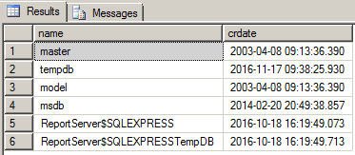
MS SQL 2012:
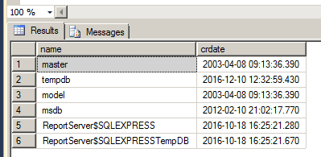
MS SQL 2008R2:
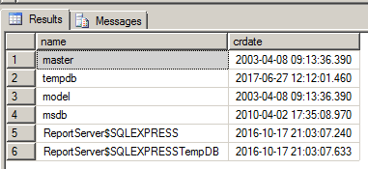

- The auditor's review of gathered documentation and facts..............
- Seems ok or should be reported

Audit Evidence:

User access to database

Method for access

- Is mixed mode disabled?
Tips to the auditor:
There are two types of authentication mechanical:
1. If Windows Authentication mode is set, only users from AD and local users can log on the server. Password Policy for MS SQL databases will be similar to Windows policy. Furthermore, one could disregard all "database local users" then they will not be able to log on.
2. If SQL Server and Windows Authentication mode (mixed mode) is selected will also local users in SQL database to log on database table and that local users will be able to avoid using Windows password policy.
Best practice recommends that one uses Windows Authentication mode, that means that only users in AD can log on databases.

Information needed/commands to run:
Log on the database server. Right-click the database server and select properties.
or
- xp_loginconfig 'login mode';

Default Value: the value is set when installed, but is default Windows Authentication Mode.

Risk: Windows provides a more robust authentication mechanism than SQL Server authentication.
Appropriate audit evidence: Result of query.
ISO/IEC 27002:2013:

Additional information:
Security Best Practices Checklist: http://technet.microsoft.com/library/Cc966456
https://msdn.microsoft.com/en-us/library/ms188470(v=sql.120).aspx
Answer:
- Facts:
MS SQL 2014
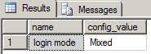
MS SQL 2012:
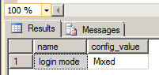
MS SQL 2008R2:
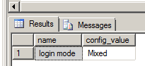
- The auditor's review of gathered documentation and facts..............
- Seems ok or should be reported

Audit Evidence:

Database management (server) level access

- Are user and group access to database management (server) level managed?
Tips to the auditor
The business should have rules for username, so in order to identify different types of users such as consultants, temporary staff and administrator / ICT users.
The purpose is to find out who can log on to the database server and manage database server (ie scroll manage accesses to all databases)
MS SQL: select * from sys.syslogins, one can see all server roles and who have each server role (there are 8 default server roles). If one uses Windows Authentication mode will all these users are in AD, and to consider whether they should have the individual role or not.
Key fields in sys.syslogins:
- Denylogin 1 = Login is a Microsoft Windows user or group and HAS BEEN denied access.
- Hasaccess 1 = Login HAS BEEN granted access to the server.
- Isntname 1 = Login is a Windows user or group.
- 0 = Login is a SQL Server login.
- Isntgroup 1 = Login is a Windows group.
- Isntuser 1 = Login is a Windows user.
One can ignore users who have denylogin = 1, or hasaccess = 0. These will not be able to log on the database server
If one uses SQL Server and Windows Autentication mode (mixed mode), must reconcile this list of active users in the database.
To find active users can run the command "select name, is_disabled, create_date, modify_date FROM sys.sql_logins", one must check the box "is_disabled" (1 = not active, 0 = active)
Fewest possible should have the sysadmin and the other roles on the database server level. Furthermore, SA accounts should not be used for regular.
Overview of standard roles (Server-Level Role) on database management level's http://technet.microsoft.com/en-us/library/ms188659(v=sql.100).aspx

Information needed/commands to run:
- select * from sys.syslogins = show all users with type of role in DBMS
- select * from sys.server_principals = show all users, type of user and if the user is active
- Additionally the script (4. Script_auditprogram_MS_SQL) will also un nest windows groups, and show all users in different groups.

Default Value
MS SQL 2014: (which are partly ok)
sa
##MS_SQLResourceSigningCertificate##
##MS_SQLReplicationSigningCertificate##
##MS_SQLAuthenticatorCertificate##
##MS_PolicySigningCertificate##
##MS_SmoExtendedSigningCertificate##
##MS_PolicyEventProcessingLogin##
##MS_PolicyTsqlExecutionLogin##
##MS_AgentSigningCertificate##
NT SERVICE\SQLWriter
NT SERVICE\Winmgmt
NT Service\MSSQL$SQLEXPRESS
BUILTIN\Users – THIS should be removed
NT AUTHORITY\SYSTEM
NT SERVICE\ReportServer$SQLEXPRESS

MS SQL 2012: (which are partly ok)
sa
##MS_SQLResourceSigningCertificate##
##MS_SQLReplicationSigningCertificate##
##MS_SQLAuthenticatorCertificate##
##MS_PolicySigningCertificate##
##MS_SmoExtendedSigningCertificate##
##MS_PolicyEventProcessingLogin##
##MS_PolicyTsqlExecutionLogin##
##MS_AgentSigningCertificate##
NT SERVICE\SQLWriter
NT SERVICE\Winmgmt
NT Service\MSSQL$SQLEXPRESS
BUILTIN\Users – THIS should be removed
NT AUTHORITY\SYSTEM
NT SERVICE\ReportServer$SQLEXPRESS

MS SQL 2008R2: (which are partly ok)
sa
##MS_SQLResourceSigningCertificate##
##MS_SQLReplicationSigningCertificate##
##MS_SQLAuthenticatorCertificate##
##MS_PolicySigningCertificate##
##MS_SmoExtendedSigningCertificate##
##MS_PolicyTsqlExecutionLogin##
NT AUTHORITY\SYSTEM
NT SERVICE\MSSQL$SQLEXPRESS
WIN-PD68CJF1PR6\admin2
BUILTIN\Users - THIS should be removed
NT AUTHORITY\NETWORK SERVICE
##MS_PolicyEventProcessingLogin##
##MS_AgentSigningCertificate##

Risk: Access to database management provides an opportunity to influence / change permissions for all databases and can affect all databases in the solution.
Appropriate audit evidence: Result of query.
ISO/IEC 27002:2013:

Additional information:
Security Best Practices Checklist:
http://technet.microsoft.com/library/Cc966456
http://msdn.microsoft.com/en-us/library/ff648235.aspx
Answer:
- Facts
MS SQL 2014:
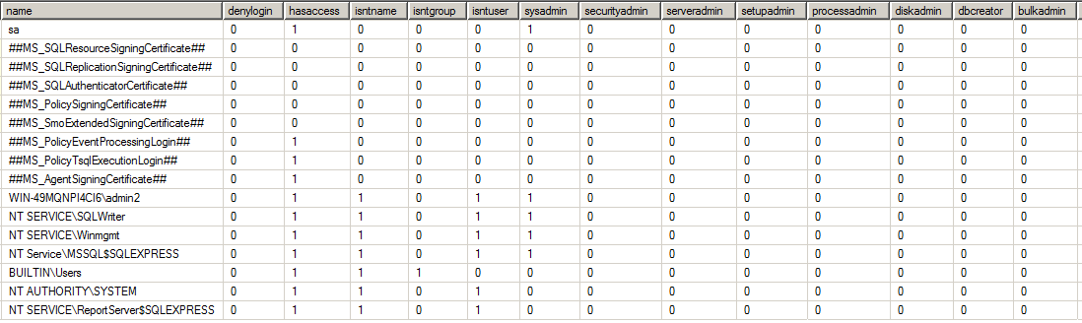

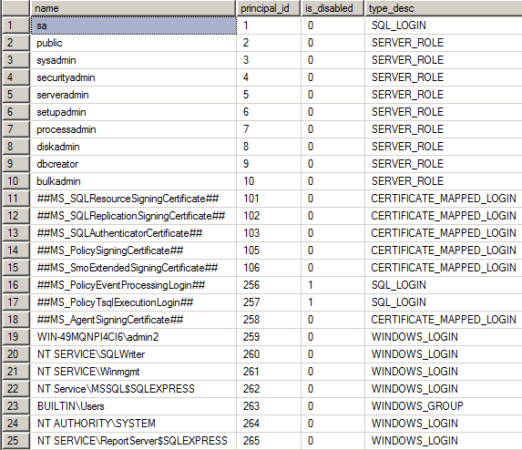

MS SQL 2012:
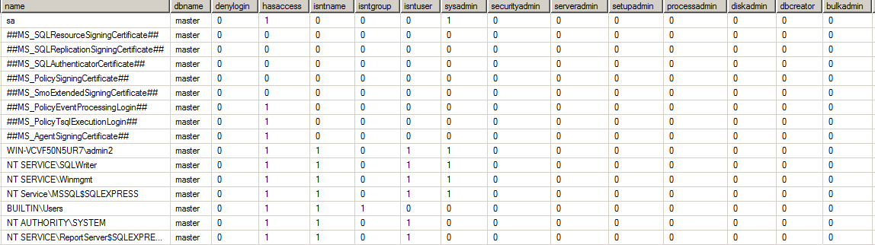
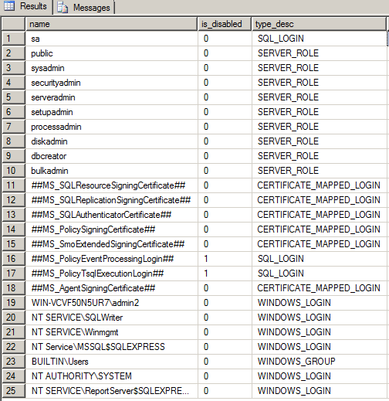

MS SQL 2008R2:
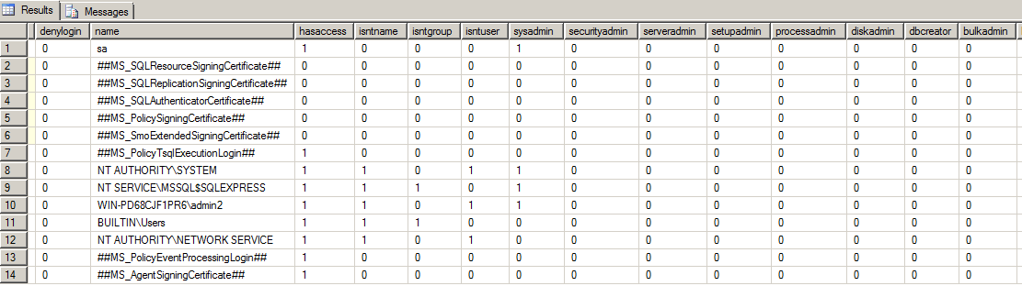
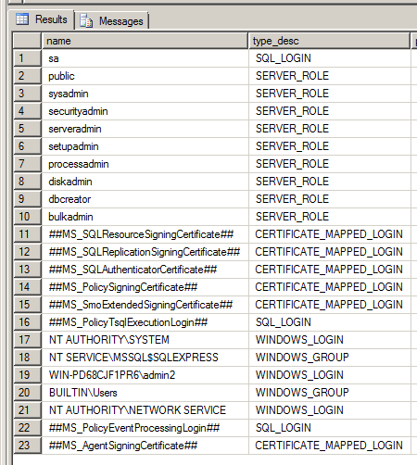

Description of roles:
Fixed server-level role | Description
sysadmin | Members of the sysadmin fixed server role can perform any activity in the server.
serveradmin | Members of the serveradmin fixed server role can change server-wide configuration options and shut down the server.
securityadmin | Members of the securityadmin fixed server role manage logins and their properties. They can GRANT, DENY, and REVOKE server-level permissions. They can also GRANT, DENY, and REVOKE database-level permissions if they have access to a database. Additionally, they can reset passwords for SQL Server logins.  ** Security Note ** The ability to grant access to the Database Engine and to configure user permissions allows the security admin to assign most server permissions. The securityadmin role should be treated as equivalent to the sysadmin role.
processadmin | Members of the processadmin fixed server role can end processes that are running in an instance of SQL Server.
setupadmin | Members of the setupadmin fixed server role can add and remove linked servers by using Transact-SQL statements. (sysadmin membership is needed when using Management Studio.)
bulkadmin | Members of the bulkadmin fixed server role can run the BULK INSERT statement.
diskadmin | The diskadmin fixed server role is used for managing disk files.
dbcreator | Members of the dbcreator fixed server role can create, alter, drop, and restore any database.
public | Every SQL Server login belongs to the public server role. When a server principal has not been granted or denied specific permissions on a securable object, the user inherits the permissions granted to public on that object. Only assign public permissions on any object when you want the object to be available to all users. You cannot change membership in public.  Note: public is implemented differently than other roles. However, permissions can be granted, denied, or revoked from public.

Who has the individual role (found by filtering the <position> = 1)
Role | Who has the role (value 1)  Is User Active?  If there are groups that have the role, who is in the group? | Seems ok or should be reported
Sysadmin
Securityadmin
Serveradmin
Setupadmin
Processadmin
Diskadmin
Dbcreator
Bulkadmin
- The auditor's review of gathered documentation and facts..............
- Seems ok or should be reported

Audit Evidence:

Database level access

- Are user and group access to the individual database managed?
Tips to the auditor:
The business should have rules for groups, this in order to identify different types of groups such as consultants, temporary staff, administrator / ICT users.
To get an overview of all databases you can run query "4. Script_auditprogram_MS_SQL"

Information needed/commands to run:
- USE [MASTER] SELECT user_name([memberuid]) as [Username], User_Name([groupuid]) as [Role_Name] FROM [sys].[sysmembers] = change MASTER to the DB you are auditing, gives you the user and roles.
- 4.0 Script_auditprogram_MS_SQL = Gives you ALL the databases
- 4.1 List ALL user right for a database = gives you ALL the user rights for one database, must add the databasename to the script OR select a database and run the script for that database.

Default Value:
Overview of standard roles in databases:
http://technet.microsoft.com/en-us/library/ms189121(v=sql.100).aspx

Risk: Lack of organization of users and groups may imply not have sufficient control on receipts for consultants, temporary workers and administrators. Error group affiliation can give users access to areas (file servers) and applications that they should not have. Access to the database level for the individual database provides an opportunity to influence the database identified.
Appropriate audit evidence: Result of query.
ISO/IEC 27002:2013:

Additional information:
Security Best Practices Checklist:
http://technet.microsoft.com/library/Cc966456
http://msdn.microsoft.com/en-us/library/ff648235.aspx
Answer:
- Facts:
MS SQL 2014 MASTER ONLY!
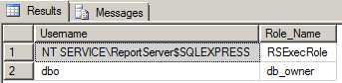

MS SQL 2012:
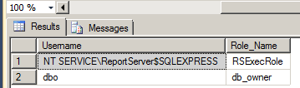

MS SQL 2008R2:
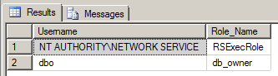

Description of roles:
db_owner | Members of the db_owner fixed database role can perform all configuration and maintenance activities on the database, and can also drop the database.
db_securityadmin | Members of the db_securityadmin fixed database role can modify role membership and manage permissions. Adding principals to this role could enable unintended privilege escalation.
db_accessadmin | Members of the db_accessadmin fixed database role can add or remove access to the database for Windows logins, Windows groups, and SQL Server logins.
db_backupoperator | Members of the db_backupoperator fixed database role can back up the database.
db_ddladmin | Members of the db_ddladmin fixed database role can run any Data Definition Language (DDL) command in a database.
db_datawriter | Members of the db_datawriter fixed database role can add, delete, or change data in all user tables.
db_datareader | Members of the db_datareader fixed database role can read all data from all user tables.
db_denydatawriter | Members of the db_denydatawriter fixed database role cannot add, modify, or delete any data in the user tables within a database.
db_denydatareader | Members of the db_denydatareader fixed database role cannot read any data in the user tables within a database.

Database | Role | Who has the role (value 1)  Is User Active?  If there are groups that have the role, who is the group | Seems ok or should be reported
 | db_owner
 | db_securityadmin
 | db_accessadmin
 | db_backupoperator
 | db_ddladmin
 | db_datawriter
 | db_datareader
 | db_denydatawriter
 | db_denydatareader

- The auditor's review of gathered documentation and facts..............
- Seems ok or should be reported

Audit Evidence:

Other access parameters

- Is CONNECT permissions on the 'guest user' is Revoked within all SQL Server databases excluding the master, msdb and tempdb?
Tips to the auditor:

Information needed/commands to run:
- USE MASTER SELECT DB_NAME() AS DBName, dpr.name, dpe.permission_name FROM sys.database_permissions dpe JOIN sys.database_principals dpr ON dpe.grantee_principal_id=dpr.principal_id WHERE dpr.name='guest' AND dpe.permission_name='CONNECT';

Or test all DBs (you will get a blank result if guest account for a particular DB doesn't have connect):

EXEC sp_MSforeachdb
'
use [?]
SELECT ''?'' AS DBName, dpr.name, dpe.permission_name FROM sys.database_permissions dpe JOIN
sys.database_principals dpr ON dpe.grantee_principal_id=dpr.principal_id WHERE dpr.name=''guest'' AND dpe.permission_name=''CONNECT'';'
GO
- 4.0 Script_auditprogram_MS_SQL

Default Value: The guest user account is added to each new database but without CONNECT permission by default.

Risk: A login assumes the identity of the guest user when a login has access to SQL Server but does not have access to a database through its own account and the database has a guest user account. Revoking the connect permission for the guest user will ensure that a login is not able to access database information without explicit access to do so.
Appropriate audit evidence: Result of query.
ISO/IEC 27002:2013:

Additional information: NA
Answer:
- Facts:
MS SQL 2014:
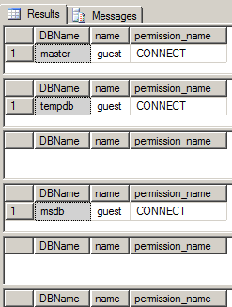

MS SQL 2012:
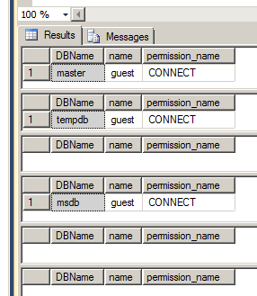

MS SQL 2008R2:
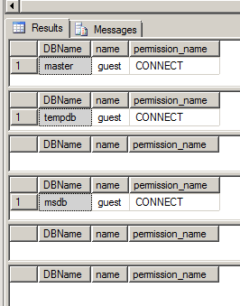
- The auditor's review of gathered documentation and facts..............
- Seems ok or should be reported

Audit Evidence:

- Are 'Orphaned Users' are Dropped from SQL Server Databases?
Tips to the auditor: after attaching or restoring of a database, previously created and configured logins in that database do not provide access ('Orphaned Users will exists in a database but not at the DBMS level).

Information needed/commands to run:
- EXEC sp_change_users_login @Action='Report';
- 4.0 Script_auditprogram_MS_SQL

Default Value:
MS SQL 2016:
By default, there is none.

Risk: Orphan users should be removed to avoid potential misuse of those broken users in any way.
Appropriate audit evidence: Result of query.
ISO/IEC 27002:2013:

Additional information: NA
Answer:
- Facts:
MS SQL 2014:
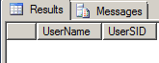
MS SQL 2012:
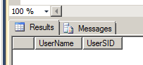
MS SQL 2008R2:
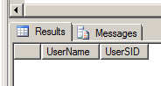
- The auditor's review of gathered documentation and facts..............
- Seems ok or should be reported

Audit Evidence:

- Ensure that the SQL Server’s MSSQL Service Account is Not an Administrator?
Tips to the auditor:
The service account and/or service SID used by the MSSQLSERVER service for a default instance or MSSQL$InstanceName service for a named instance should not be a member of the Windows Administrator group either directly or indirectly (via a group). This also means that the account known as LocalSystem (aka NT AUTHORITY\SYSTEM) should not be used for the MSSQL service as this account has higher privileges than the SQL Server service requires.

Information needed/commands to run:
Verify that the service account (in case of a local or AD account) and service SID are not members of the Windows Administrators group.
To list the users running services:
- Select * from sys.dm_server_services
- 4.0 Script_auditprogram_MS_SQL

Default Value:
MS SQL 2014:
The Service Account (or Service SID) is not a member of the Administrators group. DEFAULT OK.

Risk: Following the principle of least privilege, the service account should have no more privileges than required to do its job. For SQL Server services, the SQL Server Setup will assign the required permissions directly to the service SID. No additional permissions or privileges should be necessary.
Appropriate audit evidence: Result of query.
ISO/IEC 27002:2013:

Additional information: NA
Answer:
- Facts:
MS SQL 2014:
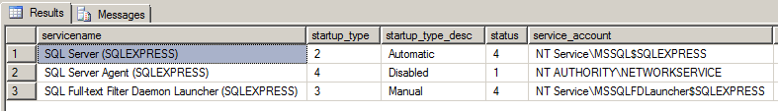
MS SQL 2012:
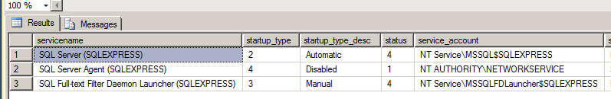
MS SQL 2008R2:
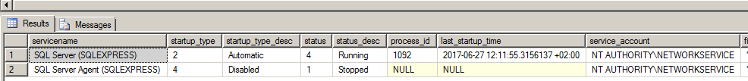
- The auditor's review of gathered documentation and facts..............
- Seems ok or should be reported

Audit Evidence:

- Ensure that the SQL Server’s SQLAgent Service Account is Not an Administrator?
Tips to the auditor:
The service account and/or service SID used by the SQLSERVERAGENT service for a default instance or SQLAGENT$InstanceName service for a named instance should not be a member of the Windows Administrator group either directly or indirectly (via a group). This also means that the account known as LocalSystem (aka NT AUTHORITY\SYSTEM) should not be used for the SQLAGENT service as this account has higher privileges than the SQL Server service requires.

Information needed/commands to run:
Verify that the service account (in case of a local or AD account) and service SID are not members of the Windows Administrators group.

To list the users running services:
- Select * from sys.dm_server_services
- 4.0 Script_auditprogram_MS_SQL

Default Value:
MS SQL 2014:
The SQL Server’s SQLAgent Service Account) is not a member of the Administrators group. DEFAULT OK.

Risk: Following the principle of least privilege, the service account should have no more privileges than required to do its job. For SQL Server services, the SQL Server Setup will assign the required permissions directly to the service SID. No additional permissions or privileges should be necessary.
Appropriate audit evidence: Result of query.
ISO/IEC 27002:2013:

Additional information: NA
Answer:
- Facts:
MS SQL 2014:
MS SQL 2012:
MS SQL 2008R2:
- The auditor's review of gathered documentation and facts..............
- Seems ok or should be reported

Audit Evidence:

- Ensure that the SQL Server’s Full-Text Service Account is Not an Administrator?
Tips to the auditor: The service account and/or service SID used by the MSSQLFDLauncher service for a default instance or MSSQLFDLauncher$InstanceName service for a named instance should not be a member of the Windows Administrator group either directly or indirectly (via a group). This also means that the account known as LocalSystem (aka NT AUTHORITY\SYSTEM) should not be used for the Full-Text service as this account has higher privileges than the SQL Server service requires.

Information needed/commands to run:
Verify that the service account (in case of a local or AD account) and service SID are not members of the Windows Administrators group.

To list the users running services:
- Select * from sys.dm_server_services
- 4.0 Script_auditprogram_MS_SQL

Default Value:
MS SQL 2014:
The SQL Server’s Full-Text Service Account is not a member of the Administrators group. DEFAULT OK.

Risk: Following the principle of least privilege, the service account should have no more privileges than required to do its job. For SQL Server services, the SQL Server Setup will assign the required permissions directly to the service SID. No additional permissions or privileges should be necessary.
Appropriate audit evidence: Result of query.
ISO/IEC 27002:2013:

Additional information: NA
Answer:
- Facts:
MS SQL 2014:
MS SQL 2012:
MS SQL 2008R2:
- The auditor's review of gathered documentation and facts..............
- Seems ok or should be reported

Audit Evidence:

Conclusion 3:

Passwords

- Are local users secured with windows password policy?
Tips to the auditor:
Extracts all local DB users, the others follow windows gpo). To find users who do not follow the SQL Server password rules must check fields:
• Is_policy_checked = 1 (1 = a follow rules, 0 = that the rules are not followed)
• Is_experation_checked = 1 (1 = a follow rules, 0 = that the rules are not followed)
These should be set to 1.

Information needed/commands to run:
- select name, is_policy_checked, is_expiration_checked, is_disabled from sys.sql_logins

Default Value:
New user is supposed to follow policy, expire password.

Risk: Risk is that user don’t follow the password policy, allowing them blanc or weak passwords.
Appropriate audit evidence: Result of query.
ISO/IEC 27002:2013:

Additional information: NA
Answer:
- Facts:
MS SQL 2014:
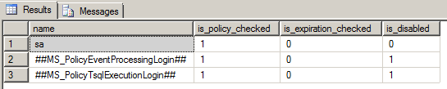
MS SQL 2012:
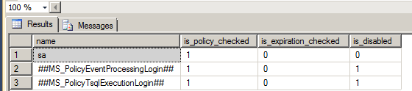
MS SQL 2008R2:
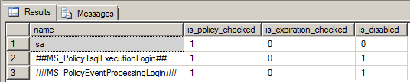
- The auditor's review of gathered documentation and facts..............
- Seems ok or should be reported

Audit Evidence:

- Are windows password settings sufficient?
Tips to the auditor:

Information needed/commands to run:
- In windows run secpol.msc

Default Value:
At windows run: run secpol.msc, then select Account Policy and select password policy and Account lockout policy. There default depends on the windows version.

Risk: Risk is that the password policy in windows is weak., and unauthorized access.

Appropriate audit evidence: secpol.msc
ISO/IEC 27002:2013:

Additional information:
https://technet.microsoft.com/en-us/library/jj852214(v=ws.11).aspx
Answer:
- Facts:
Windows server 2008
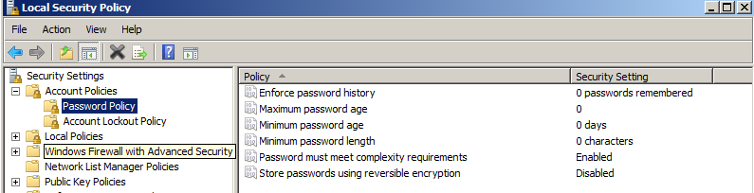
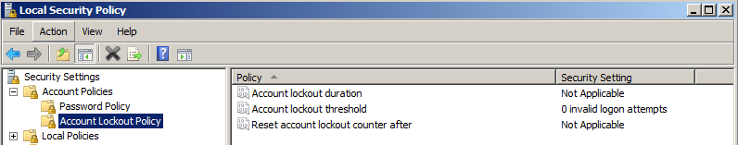

- The auditor's review of gathered documentation and facts..............
- Seems ok or should be reported

Audit Evidence:

- Do all local users have a password?
Tips to the auditor:

Information needed/commands to run:
- Select name from sys.sql_logins where pwdcompare('', password_hash) = 1
- 4.0 Script_auditprogram_MS_SQL

Default Value: No default value.

Risk: If the some of the users don't follow windows policy they might have blanc password. And the windows policy don’t allow blanc password…….
Appropriate audit evidence: Result of query.
ISO/IEC 27002:2013:

Additional information: NA
Answer:
- Facts:
MS SQL 2014
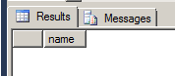
MS SQL 2012:
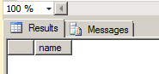
MS SQL 2008R2:
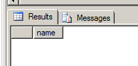
- The auditor's review of gathered documentation and facts..............
- Seems ok or should be reported

Audit Evidence:

- Have all local users change the default password?
Tips to the auditor:

Information needed/commands to run:
- Select name from sys.sql_logins where pwdcompare('defaultpassword', password_hash) = 1
- Not a part of the script.

Default Value: Most companies use a default password when creating accounts, this should be changed.

Risk: If default password is in use, it's easy for other people to misuse the account.
Appropriate audit evidence: Result of query.
ISO/IEC 27002:2013:

Additional information: NA
Answer:
- Facts:
MS SQL 2014 There are NO default passwords
MS SQL 2012:
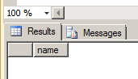
MS SQL 2008R2:
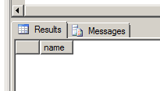
- The auditor's review of gathered documentation and facts..............
- Seems ok or should be reported

Audit Evidence:

- Have all local users not used their name as a password?
Tips to the auditor:

Information needed/commands to run:
- Select name from sys.sql_logins where pwdcompare (name,password_hash)=1;

Default Value: Most companies use a default password when creating accounts, this should be changed.

Risk: If default password is in use, it's easy for other people to misuse the account.
Appropriate audit evidence: Result of query.
ISO/IEC 27002:2013:
Additional information:
https://www.mssqltips.com/sqlservertip/2775/identify-blank-and-weak-passwords-for-sql-server-logins/
http://sqlmag.com/t-sql/find-weak-database-passwords
http://sqlity.net/en/2455/pwdcompare/
Answer:
- -Facts:
MS SQL 2014
MS SQL 2012:
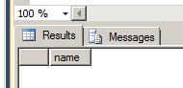
MS SQL 2008R2:
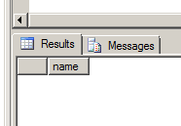
- The auditor's review of gathered documentation and facts..............
- Seems ok or should be reported

Audit Evidence:

Surface area reduction

- Is 'Ad Hoc Distributed Queries' Server Configuration Option is set to '0'?
Tips to the auditor:
Ad Hoc Distributed Queries Allow users to query data and execute statements on external data sources. This functionality should be disabled
.
Information needed/commands to run:
- SELECT name, CAST(value as int) as value_configured, CAST(value_in_use as int) as value_in_use FROM sys.configurations WHERE name = 'ad hoc distributed queries';

For all important parameters:
SELECT name, CAST(value as int) as value_configured,
CAST(value_in_use as int) as value_in_use
FROM sys.configurations
WHERE name IN ('ad hoc distributed queries', 'clr enabled', 'Cross db ownership chaining',
'Database Mail XPs', 'Ole Automation Procedures', 'Remote access', 'Remote admin connections', 'Scan for startup procs');

Both value columns must show 0.

Default Value:
MS SQL 2014 - Both value columns show 0.

Risk: This feature can be used to remotely access and exploit vulnerabilities on remote SQL Server instances and to run unsafe Visual Basic for Application functions.
Appropriate audit evidence: Result of query.
ISO/IEC 27002:2013:

Additional information: NA
Answer:
- Facts:
MS SQL 2014:
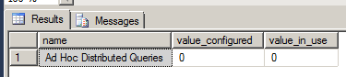
MS SQL 2012:
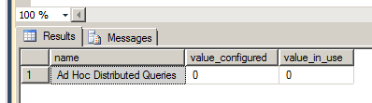
MS SQL 2008R2:
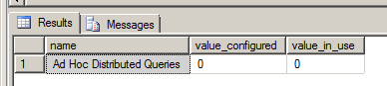
- The auditor's review of gathered documentation and facts..............
- Seems ok or should be reported

Audit Evidence:

- Is 'CLR Enabled' Server Configuration Option is set to '0'?
Tips to the auditor:
The CLR enabled option specifies whether user assemblies can be run by SQL Server.

Managed database objects, such as stored procedures or triggers, are compiled and then deployed in units called an assembly.

Information needed/commands to run:
- SELECT name, CAST(value as int) as value_configured, CAST(value_in_use as int) as value_in_use FROM sys.configurations WHERE name = 'clr enabled';

For all important parameters:
SELECT name, CAST(value as int) as value_configured,
CAST(value_in_use as int) as value_in_use
FROM sys.configurations
WHERE name IN ('ad hoc distributed queries', 'clr enabled', 'Cross db ownership chaining',
'Database Mail XPs', 'Ole Automation Procedures', 'Remote access', 'Remote admin connections', 'Scan for startup procs');

Both value columns must show 0.

Default Value:
MS SQL 2014 - Both value columns show 0.

Risk: Enabling use of CLR assemblies widens the attack surface of SQL Server and puts it at risk from both inadvertent and malicious assemblies.
Appropriate audit evidence: Result of query.
ISO/IEC 27002:2013:

Additional information:
https://msdn.microsoft.com/en-us/library/ms345106.aspx
Answer:
- Facts:
MS SQL 2014:
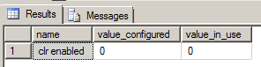
MS SQL 2012:
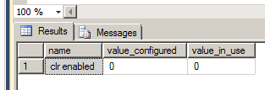
MS SQL 2008R2:
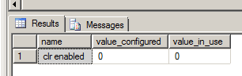
- The auditor's review of gathered documentation and facts..............
- Seems ok or should be reported

Audit Evidence:

- Is 'Cross DB Ownership Chaining' Server Configuration Option is set to '0' ?
Tips to the auditor:

Information needed/commands to run:
- SELECT name, CAST(value as int) as value_configured, CAST(value_in_use as int) as value_in_use FROM sys.configurations WHERE name = 'Cross db ownership chaining';

For all important parameters:
SELECT name, CAST(value as int) as value_configured,
CAST(value_in_use as int) as value_in_use
FROM sys.configurations
WHERE name IN ('ad hoc distributed queries', 'clr enabled', 'Cross db ownership chaining',
'Database Mail XPs', 'Ole Automation Procedures', 'Remote access', 'Remote admin connections', 'Scan for startup procs');

Both value columns must show 0.

Default Value:
MS SQL 2014 - Both value columns show 0.

Risk: When enabled, this option allows a member of the db_owner role in a database to gain access to objects owned by a login in any other database, causing an unnecessary information disclosure. When required, cross-database ownership chaining should only be enabled for the specific databases requiring it instead of at the instance level for all databases by using the ALTER DATABASE <dbname> SET DB_CHAINING ON command. This database option may not be changed on the master, model, or tempdb system databases.
Appropriate audit evidence: Result of query.
ISO/IEC 27002:2013:

Additional information: NA
Answer:
- Facts:
MS SQL 2014:
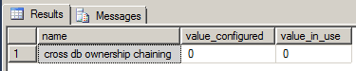
MS SQL 2012:
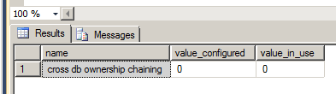
MS SQL 2008R2:
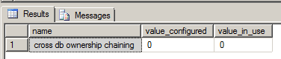
- The auditor's review of gathered documentation and facts..............
- Seems ok or should be reported

Audit Evidence:

- Is Ensure 'Database Mail XPs' Server Configuration Option is set to '0'
Tips to the auditor:
This option controls the generation and transmission of email messages from SQL Server.

Information needed/commands to run:
- SELECT name, CAST(value as int) as value_configured, CAST(value_in_use as int) as value_in_use FROM sys.configurations WHERE name = 'Database Mail XPs';

For all important parameters:
SELECT name, CAST(value as int) as value_configured,
CAST(value_in_use as int) as value_in_use
FROM sys.configurations
WHERE name IN ('ad hoc distributed queries', 'clr enabled', 'Cross db ownership chaining',
'Database Mail XPs', 'Ole Automation Procedures', 'Remote access', 'Remote admin connections', 'Scan for startup procs');

Both value columns must show 0.

Default Value:
MS SQL 2014 - Both value columns show 0.

Risk: Disabling Database Mail reduces the SQL Server surface, eliminates a DOS attack vector and channel to exfiltrate data from the database server to a remote host.
Appropriate audit evidence: Result of query.
ISO/IEC 27002:2013:

Additional information: NA
Answer:
- Facts:
MS SQL 2014:
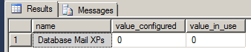
MS SQL 2012:
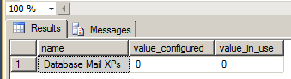
MS SQL 2008R2:
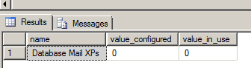
- The auditor's review of gathered documentation and facts..............
- Seems ok or should be reported

Audit Evidence:

- Is 'Ole Automation Procedures' Server Configuration Option is set to '0'?
Tips to the auditor:
Extended stored procedures that allow SQL Server users to execute functions external to SQL Server.

Information needed/commands to run:
- SELECT name, CAST(value as int) as value_configured, CAST(value_in_use as int) as value_in_use FROM sys.configurations WHERE name = 'Ole Automation Procedures';

For all important parameters:
SELECT name, CAST(value as int) as value_configured,
CAST(value_in_use as int) as value_in_use
FROM sys.configurations
WHERE name IN ('ad hoc distributed queries', 'clr enabled', 'Cross db ownership chaining',
'Database Mail XPs', 'Ole Automation Procedures', 'Remote access', 'Remote admin connections', 'Scan for startup procs');

Both value columns must show 0.

Default Value:
MS SQL 2014 - Both value columns show 0.

Risk: Enabling this option will increase the attack surface of SQL Server and allow users to execute functions in the security context of SQL Server.
Appropriate audit evidence: Result of query.
ISO/IEC 27002:2013:

Additional information: NA
Answer:
- Facts:
MS SQL 2014:
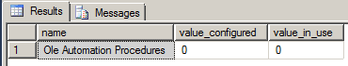
MS SQL 2012:
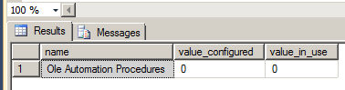
MS SQL 2008R2:
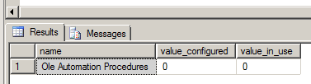
- The auditor's review of gathered documentation and facts..............
- Seems ok or should be reported

Audit Evidence:

- Is 'Remote Access' Server Configuration Option is set to '0'?
Tips to the auditor:

Information needed/commands to run:
- SELECT name, CAST(value as int) as value_configured, CAST(value_in_use as int) as value_in_use FROM sys.configurations WHERE name = 'Remote access';

For all important parameters:
SELECT name, CAST(value as int) as value_configured,
CAST(value_in_use as int) as value_in_use
FROM sys.configurations
WHERE name IN ('ad hoc distributed queries', 'clr enabled', 'Cross db ownership chaining',
'Database Mail XPs', 'Ole Automation Procedures', 'Remote access', 'Remote admin connections', 'Scan for startup procs');

Both value columns must show 0.

Default Value:
MS SQL 2014 - Both value columns show 1.

Risk: Functionality can be abused to launch a Denial-of-Service (DoS) attack on remote servers by off-loading query processing to a target.
Appropriate audit evidence: Result of query.
ISO/IEC 27002:2013:

Additional information: NA
Answer:
- Facts:
MS SQL 2014:
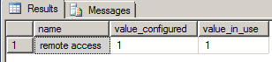
MS SQL 2012:

MS SQL 2008R2:
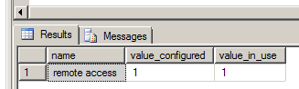
- The auditor's review of gathered documentation and facts..............
- Seems ok or should be reported

Audit Evidence:

- Is 'Remote Admin Connections' Server Configuration Option is set to '0'?
Tips to the auditor:

Information needed/commands to run:
- SELECT name, CAST(value as int) as value_configured, CAST(value_in_use as int) as value_in_use FROM sys.configurations WHERE name = 'Remote admin connections' AND SERVERPROPERTY('IsClustered') = 0;

For all important parameters:
SELECT name, CAST(value as int) as value_configured,
CAST(value_in_use as int) as value_in_use
FROM sys.configurations
WHERE name IN ('ad hoc distributed queries', 'clr enabled', 'Cross db ownership chaining',
'Database Mail XPs', 'Ole Automation Procedures', 'Remote access', 'Remote admin connections', 'Scan for startup procs');

If no data is returned, the instance is a cluster and this recommendation is not applicable. If data is returned, then both the value columns must show 0.

Default Value:
MS SQL 2014 - Both value columns show 0.

Risk: The Dedicated Administrator Connection (DAC) lets an administrator access a running server to execute diagnostic functions or Transact-SQL statements, or to troubleshoot problems on the server, even when the server is locked or running in an abnormal state and not responding to a SQL Server Database Engine connection. In a cluster scenario the administrator may not actually be logged on to the same node that is currently hosting the SQL Server instance and thus is considered "remote". Therefore, this setting should usually be enabled (1) for SQL Server failover clusters; otherwise it should be disabled (0) which is the default.
Appropriate audit evidence: Result of query.
ISO/IEC 27002:2013:

Additional information: NA
Answer:
- Facts:
MS SQL 2014:
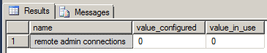
MS SQL 2012:
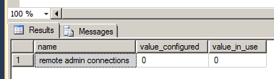
MS SQL 2008R2:
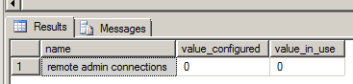
- The auditor's review of gathered documentation and facts..............
- Seems ok or should be reported

Audit Evidence:

- Is 'Scan for Startup Procs' Server Configuration Option is set to '0'?
Tips to the auditor:

Information needed/commands to run:
- SELECT name, CAST(value as int) as value_configured, CAST(value_in_use as int) as value_in_use FROM sys.configurations WHERE name = 'Scan for startup procs';

For all important parameters:
SELECT name, CAST(value as int) as value_configured,
CAST(value_in_use as int) as value_in_use
FROM sys.configurations
WHERE name IN ('ad hoc distributed queries', 'clr enabled', 'Cross db ownership chaining',
'Database Mail XPs', 'Ole Automation Procedures', 'Remote access', 'Remote admin connections', 'Scan for startup procs');

Both value columns must show 0.

Default Value:
MS SQL 2014 - Both value columns show 0.

Risk: Enforcing this control reduces the threat of an entity leveraging these facilities for malicious purposes.
Appropriate audit evidence: Result of query.
ISO/IEC 27002:2013:

Additional information: NA
Answer:
- Facts:
MS SQL 2014:
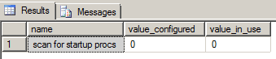
MS SQL 2012:
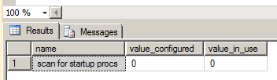
MS SQL 2008R2:
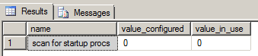
- The auditor's review of gathered documentation and facts..............
- Seems ok or should be reported

Audit Evidence:

- Is 'Trustworthy' Database Property is set to 'Off'?
Tips to the auditor:
The TRUSTWORTHY option allows database objects to access objects in other database under certain circumstances.

Information needed/commands to run:
- SELECT name FROM sys.databases WHERE is_trustworthy_on = 1 AND name != 'msdb' AND state = 0;

No rows should be returned.

Default Value:
MS SQL 2014 - no output.

Risk: Provides protection from malicious CLR assemblies or extended procedures.

Appropriate audit evidence: Result of query.
ISO/IEC 27002:2013:
Additional information: NA
Answer:
- Facts:
MS SQL 2014:
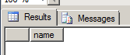
MS SQL 2012:
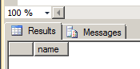
MS SQL 2008R2:
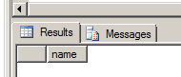
- The auditor's review of gathered documentation and facts..............
- Seems ok or should be reported

Audit Evidence:

- Ensure Unnecessary SQL Server Protocols are set to 'Disabled'?
Tips to the auditor:
SQL Server supports Shared Memory, Named Pipes, TCP/IP and VIA protocols. However, SQL Server should be configured to use the bare minimum required based on the organization's needs.

Information needed/commands to run:
Open SQL Server Configuration Manager; go to the SQL Server Network Configuration. Ensure that only required protocols are enabled.

Default Value:
MS SQL 2014 - no output.

Risk: Using fewer protocols minimizes the attack surface of SQL Server and in some cases can protect it from remote attacks.
Appropriate audit evidence: Result of query.
ISO/IEC 27002:2013:

Additional information: NA
Answer:
- Facts:
MS SQL 2014:
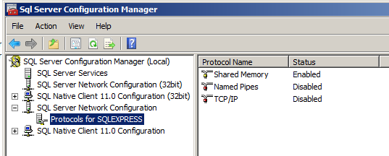
MS SQL 2012:
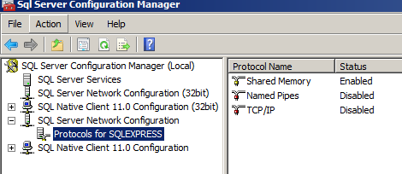
MS SQL 2008R2:
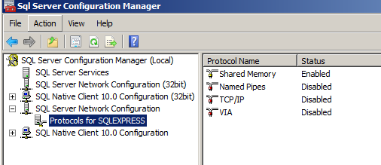

- The auditor's review of gathered documentation and facts..............
- Seems ok or should be reported

Audit Evidence:

- Is SQL Server is configured to use non-standard ports?
Tips to the auditor:
If enabled, the default SQL Server instance will be assigned a default port of TCP:1433 for TCP/IP communication. Administrators can also configure named instances to use TCP:1433 for communication. TCP:1433 is a widely known SQL Server port and this port assignment should be changed.

Information needed/commands to run:
In powershell: netstat -ano|select-string 1433.+listening

This should return no lines. If any lines returned, check the process id in the last column if it's a SQL Server instance.

Default Value:
MS SQL 2014 - no output.

Risk: Using a non-default port helps protect the database from attacks directed to the default port.
Appropriate audit evidence: Result of query.
ISO/IEC 27002:2013:

Additional information: NA
Answer:
- Facts:
MS SQL 2014:
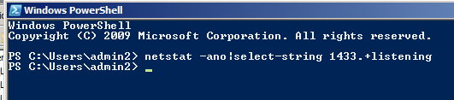
MS SQL 2012:
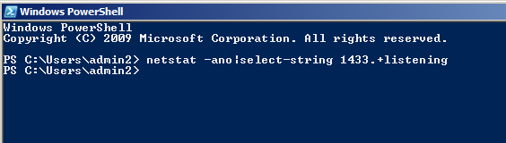
MS SQL 2008R2:
- The auditor's review of gathered documentation and facts..............
- Seems ok or should be reported

Audit Evidence:

- Is 'Hide Instance' option is set to 'Yes' for Production SQL Server instances?
Tips to the auditor:
Non-clustered SQL Server instances within production environments should be designated as hidden to prevent advertisement by the SQL Server Browser service.

Information needed/commands to run:
- DECLARE @getValue INT; EXEC master..xp_instance_regread @rootkey = N'HKEY_LOCAL_MACHINE', @key = N'SOFTWARE\Microsoft\Microsoft SQL Server\MSSQLServer\SuperSocketNetLib', @value_name = N'HideInstance', @value = @getValue OUTPUT; SELECT @getValue;

Default Value:
MS SQL 2014 - value 0 (By default, SQL Server instances are not hidden.)

Risk: Designating production SQL Server instances as hidden leads to a more secure installation because they cannot be enumerated. However, clustered instances may break if this option is selected.
Appropriate audit evidence: Result of query.
ISO/IEC 27002:2013:

Additional information: NA
Answer:
- Facts:
MS SQL 2014:
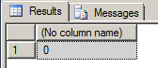
MS SQL 2012:
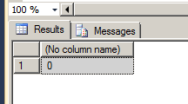
MS SQL 2008R2:
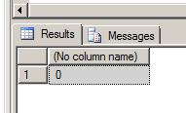
- The auditor's review of gathered documentation and facts..............
- Seems ok or should be reported

Audit Evidence:

- Is 'sa' Login Account is set to 'Disabled'?
Tips to the auditor:
The sa account is a widely known and often widely used SQL Server account with sysadmin privileges.

Information needed/commands to run:
- SELECT name, is_disabled FROM sys.server_principals WHERE sid = 0x01;

Default Value:
MS SQL 2014 - value 0

Risk: Enforcing this control reduces the probability of an attacker executing brute force attacks against a well-known principal.
Appropriate audit evidence: Result of query.
ISO/IEC 27002:2013:

Additional information: NA
Answer:
- Facts:
MS SQL 2014:
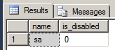
MS SQL 2012:
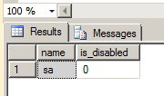
MS SQL 2008R2:
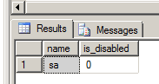

- The auditor's review of gathered documentation and facts..............
- Seems ok or should be reported

Audit Evidence:

- Is 'sa' Login Account been renamed?
Tips to the auditor:
The sa account is a widely known and often widely used SQL Server account with sysadmin privileges.

Information needed/commands to run:
SELECT name FROM sys.server_principals WHERE sid = 0x01

Default Value:
MS SQL 2014 - sa

Risk: It is more difficult to launch password-guessing and brute-force attacks against the sa account if the username is not known.
Appropriate audit evidence: Result of query.
ISO/IEC 27002:2013:

Additional information: NA
Answer:
- Facts:
MS SQL 2014:
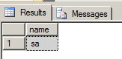
MS SQL 2012:
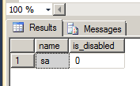
MS SQL 2008R2:
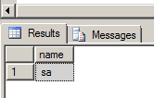
- The auditor's review of gathered documentation and facts..............
- Seems ok or should be reported

Audit Evidence:

- Is 'xp_cmdshell' Server Configuration Option is set to '0'?
Tips to the auditor:
The xp_cmdshell procedure allows an authenticated SQL Server user to execute operating-system command shell commands and return results as rows within the SQL client. I.e with the command EXEC xp_cmdshell 'dir c:' list the content of c:.

Information needed/commands to run:
- EXECUTE sp_configure 'xp_cmdshell';

Default Value:
MS SQL 2014 - 0

Risk: xp_cmdshell is commonly used by attackers to read or write data to/from the underlying Operating System of a database server.
Appropriate audit evidence: Result of query.
ISO/IEC 27002:2013:

Additional information: NA
Answer:
- Facts:
MS SQL 2014:
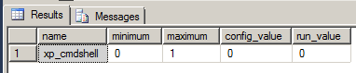
MS SQL 2012:
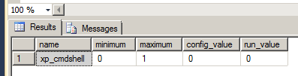
MS SQL 2008R2:
Dos not exist.

- The auditor's review of gathered documentation and facts..............
- Seems ok or should be reported

Audit Evidence:

- Is 'AUTO_CLOSE OFF' set on contained databases?
Tips to the auditor: AUTO_CLOSE determines if a given database is closed or not after a connection terminates. If enabled, subsequent connections to the given database will require the database to be reopened and relevant procedure caches to be rebuilt.

A contained database is an isolated database.

Information needed/commands to run:
- SELECT name, containment, containment_desc, is_auto_close_on FROM sys.databases WHERE containment <> 0 and is_auto_close_on = 1;

Default Value:
MS SQL 2014 - No value

Risk: Opening contained databases to authenticate a user consumes additional server resources and may contribute to a denial of service.
Appropriate audit evidence: Result of query.
ISO/IEC 27002:2013:

Additional information: NA
Answer:
- Facts:
MS SQL 2014:
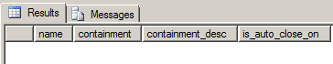
MS SQL 2012:
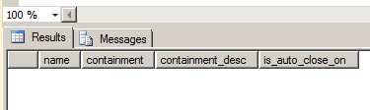
MS SQL 2008R2:
Dos not exist.

- The auditor's review of gathered documentation and facts..............
- Seems ok or should be reported

Audit Evidence:

- Is 'sa' login name in used?
Tips to the auditor:
The 'sa' login (e.g. principal) is a widely known and often widely used SQL Server account. Therefore, there should not be a login called 'sa' when the original 'sa' login (sid 0x01) has been renamed.

Information needed/commands to run:
- SELECT sid, name FROM sys.server_principals WHERE name = 'sa' AND sid <> 0x01;

This query should not return any rows.

Default Value:
MS SQL 2014 - no hit

Risk: Enforcing this control reduces the probability of an attacker executing brute force attacks against a well-known principal.

Appropriate audit evidence: Result of query.
ISO/IEC 27002:2013:

Additional information: NA
Answer:
- Facts:
MS SQL 2014:
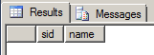
MS SQL 2012:
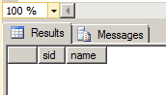
MS SQL 2008R2:
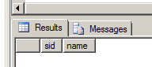
- The auditor's review of gathered documentation and facts..............
- Seems ok or should be reported

Audit Evidence:

Audit and logging

- Are 'Maximum number of error log files' is set to greater than or equal to '12'?
Tips to the auditor:

Information needed/commands to run:
DECLARE @NumErrorLogs int; EXEC master.sys.xp_instance_regread N'HKEY_LOCAL_MACHINE', N'Software\Microsoft\MSSQLServer\MSSQLServer', N'NumErrorLogs', @NumErrorLogs OUTPUT; SELECT ISNULL(@NumErrorLogs, -1) AS [NumberOfLogFiles];

Or

1. Open SQL Server Management Studio.
2. Open Object Explorer and connect to the target instance.
3. Navigate to the Management tab in Object Explorer and expand. Right click on the SQL Server Logs file and select Configure.
4. Verify the Limit the number of error log files before they are recycled checkbox is checked
5. Verify the Maximum number of error log files is greater than or equal to 12

Default Value: 6.
MS SQL 2014: - value -1 (the value is not set, but in practice = 6)

Risk: The SQL Server errorlog contains important information about major server events and login attempt information as well.

Appropriate audit evidence: Result of query.
ISO/IEC 27002:2013:
Additional information: NA
Answer:
- Facts:
MS SQL 2014:
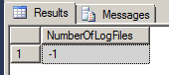
MS SQL 2012:
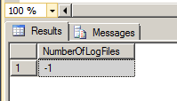
MS SQL 2008R2:
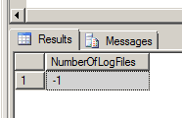
- The auditor's review of gathered documentation and facts..............
- Seems ok or should be reported

Audit Evidence:

- Is 'Default Trace Enabled' Server Configuration Options set to '1'?
Tips to the auditor:
The default trace provides audit logging of database activity including account creations, privilege elevation and execution of DBCC commands.

Information needed/commands to run:
- SELECT name, CAST(value as int) as value_configured, CAST(value_in_use as int) as value_in_use FROM sys.configurations WHERE name = 'Default trace enabled';

Both value columns must show 1.

Default Value:
MS SQL 2014: 1

Risk: Default trace provides valuable audit information regarding security-related activities on the server.

Appropriate audit evidence: Result of query.
ISO/IEC 27002:2013:
Additional information:
http://msdn.microsoft.com/en-us/library/ms175513(v=sql.120).aspx
Answer:
- Facts:
MS SQL 2014:
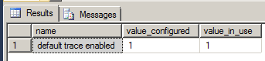
MS SQL 2012:
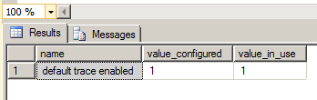
MS SQL 2008R2:
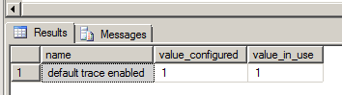

- The auditor's review of gathered documentation and facts..............
- Seems ok or should be reported

Audit Evidence:

- Is 'Login Auditing' set to both 'failed logins' and success?
Tips to the auditor:
Vi bør kreve begge to, dette for å se hvem som en har "tittet" på data

Information needed/commands to run:
- XP_loginconfig 'audit level';
- Right click on database server and select property, and select Security.

Default Value:
MS SQL 2014: Failed logins only

Risk: If only failed logins are logged the company is not able to see who has logged inn to the system.

Appropriate audit evidence: Result of query.
ISO/IEC 27002:2013:
Additional information: NA
Answer:
- Facts:
MS SQL 2014:
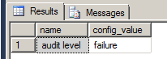
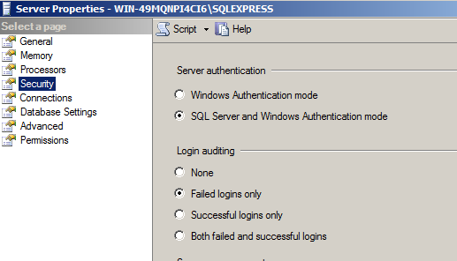
MS SQL 2012:
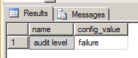
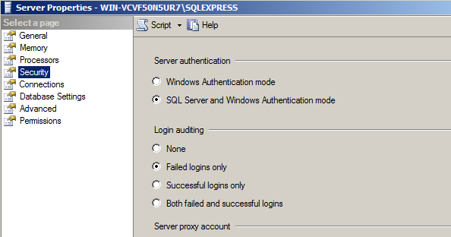

MS SQL 2008R2:
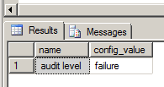

- The auditor's review of gathered documentation and facts..............
- Seems ok or should be reported

Audit Evidence:

- Is 'SQL Server Audit' set to capture both 'failed' and 'successful logins''?
Tips to the auditor: SQL Server Audit is capable of capturing both failed and successful logins and writing them to one of three places: the application event log, the security event log, or the file system. We will use it to capture any login attempt to SQL Server, as well as any attempts to change audit policy. This will also serve to be a second source to record failed login attempts.
Information needed/commands to run:
SELECT S.name AS 'Audit Name' , CASE S.is_state_enabled WHEN 1 THEN 'Y' WHEN 0 THEN 'N' END AS 'Audit Enabled' , S.type_desc AS 'Write Location' , SA.name AS 'Audit Specification Name' , CASE SA.is_state_enabled WHEN 1 THEN 'Y' WHEN 0 THEN 'N' END AS 'Audit Specification Enabled' , SAD.audit_action_name , SAD.audited_result FROM sys.server_audit_specification_details AS SAD JOIN sys.server_audit_specifications AS SA ON SAD.server_specification_id = SA.server_specification_id JOIN sys.server_audits AS S ON SA.audit_guid = S.audit_guid WHERE SAD.audit_action_id IN ('CNAU', 'LGFL', 'LGSD');

Default Value:
MS SQL 2014: no output

Risk: By utilizing Audit instead of the traditional setting under the Security tab to capture successful logins, we reduce the noise in the ERRORLOG. This keeps it smaller and easier to read for DBAs who are attempting to troubleshoot issues with the SQL Server. Also, the Audit object can write to the security event log, though this requires operating system configuration. This gives an additional option for where to store login events, especially in conjunction with an SIEM.

Appropriate audit evidence: Result of query.
ISO/IEC 27002:2013:
Additional information:
http://msdn.microsoft.com/en-us/library/ms175513(v=sql.120).aspx
Answer:
- Facts:
MS SQL 2014:
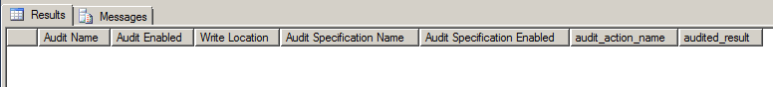
MS SQL 2012:
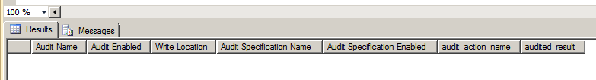
MS SQL 2008R2:
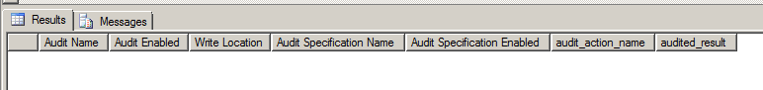
- The auditor's review of gathered documentation and facts..............
- Seems ok or should be reported

Audit Evidence:

- Are audit log sufficient?
Tips to the auditor:
The auditor should look at logs if necessary for the audit.

Information needed/commands to run:
- Run script 4.4 Audit logs(v1.0)

More to be added at a later time.

Risk:
Appropriate audit evidence: Result of query.
ISO/IEC 27002:2013:

Additional information:
https://www.simple-talk.com/sql/performance/the-default-trace-in-sql-server-the-power-of-performance-and-security-auditing/
Answer:
- Facts:
MS SQL 2014:
MS SQL 2012:
MS SQL 2008R2:

- The auditor's review of gathered documentation and facts..............
- Seems ok or should be reported

Audit Evidence:

Version, updates and patches

- Is the version in use supported by Microsoft?
Tips to the auditor:

Information needed/commands to run:
- Select @@version

Risk: If unsupported version is in use it may not function as wanted or its insecure.
Appropriate audit evidence: Result of query.
ISO/IEC 27002:2013:

Additional information:
https://victoriayudin.com/2008/10/29/when-does-my-sql-server-support-end/
https://support.microsoft.com/nb-no/gp/lifeselectindex
Answer:
- Facts:
MS SQL 2014:
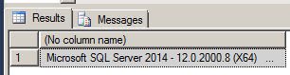
MS SQL 2012:
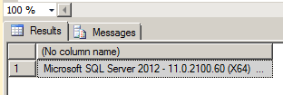
MS SQL 2008R2:
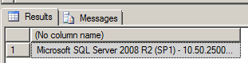
- The auditor's review of gathered documentation and facts..............
- Seems ok or should be reported

Audit Evidence:

- Are the MS SQL server been sufficient updated?
Tips to the auditor:

Information needed/commands to run:
Look for summary.txt in the Windows folder:
- C:\Program Files\Microsoft SQL Server\%%%Setup> Bootstrap\Log.
i.e MS SQL 2014: C:\Program Files\Microsoft SQL Server\120\Setup Bootstrap\Log
i.e MS SQL 2012: C:\Program Files\Microsoft SQL Server\110\Setup Bootstrap\Log

First column returns the installed Service Pack level, the second is the exact build number.

Default Value: Service packs and patches are not installed by default.

Risk: Using the most recent SQL Server software, along with all applicable patches can help limit the possibilities for vulnerabilities in the software, the installation version and/or patches applied during setup should be established according to the needs of the organization.
Appropriate audit evidence: Result of query.
ISO/IEC 27002:2013:

Additional information:
http://www.cvedetails.com/version-list/26/251/1/Microsoft-Sql-Server.html
Hotfixes and Cumulative updates: http://blogs.msdn.com/b/sqlreleaseservices/
Service Packs: https://support.microsoft.com/en-us/kb/2958069
http://sqlserverbuilds.blogspot.no/
Answer:
- Facts:
MS SQL 2014:
MS SQL 2012:
MS SQL 2008R2:

- The auditor's review of gathered documentation and facts..............
- Seems ok or should be reported

Audit Evidence:

Total conclusion

Appendix 1: Collection of data
Query | Explanation: | Used in audit action
select name, crdate from sysdatabases | Show all the databases | 2 a)
xp_loginconfig 'login mode'; | Identified mixed mode | 3.1 a)
select * from sys.syslogins  select * from sys.server_principals | show all users with type of role in DBMS  show all users, type of user and if the user is active | 3.2 a)
USE <database name> SELECT user_name ([memberuid]) as [User Name] USER_NAME ([groupuid]) as [role_name] FROM [sys]. [Sysmembers]  AND  4. Script_auditprogram_MS_SQL  4.1 List ALL user right for a database | Extract users and groups  Script 4 Gives you ALL the databases  Script 4.1 gives you ALL the user rights for one database, must add the databasename to the script OR select a database and run the script for that database. | 3.3 a)
Sp_MSforeachdb  USE [?]  Select ''?'' AS DBName, dpr.name, dpe.permission_name FROM sys.database_permissions dpe JOIN sys.database_principals dpr ON dpe.grantee_principal_id=dpr.principal_id WHERE dpr.name=''guest'' AND dpe.permission_name=''CONNECT''; | To test if guest user can connect. | 3.4 a)
EXEC sp_change_users_login @Action='Report';  GO | Test if orphan user are dropped | 3.4 b)
Select * from sys.dm_server_services | Test what account the service user uses | 3.4 c), d) and e)
select name, is_policy_checked, is_expiration_checked, is_disabled from sys.sql_logins | Does the local users follow the windows password policy | 4 a)
secpol.msc | In windows run secpol.msc | 4 b)
Select name from sys.sql_logins where pwdcompare('', password_hash) = 1 | Does the local users have blank passwords | 4 c)
Select name from sys.sql_logins where pwdcompare('defaultpassword', password_hash) = 1 | Have all local users change the default password  You need to update the script whit the default password | 4 d)
Select name from sys.sql_logins where pwdcompare (name,password_hash)=1; | Have any users used their name as the password? | 4 e)
SELECT name, CAST(value as int) as value_configured,  CAST(value_in_use as int) as value_in_use  FROM sys.configurations  WHERE name IN ('ad hoc distributed queries', 'clr enabled', 'Cross db ownership chaining',  'Database Mail XPs', 'Ole Automation Procedures', 'Remote access', 'Remote admin connections', 'Scan for startup procs'); | Different values in sys.configurations | 5 a) - h)
SELECT name FROM sys.databases WHERE is_trustworthy_on = 1 AND name != 'msdb' AND state = 0; | Is trustworthy set to off | 5 i)
In powershell: netstat -ano|select-string 1433.+listening | Windows powershell, to identify what port is in use | 5 k)
DECLARE @getValue INT; EXEC master..xp_instance_regread @rootkey = N'HKEY_LOCAL_MACHINE',  @key = N'SOFTWARE\Microsoft\Microsoft SQL Server\MSSQLServer\SuperSocketNetLib',  @value_name = N'HideInstance', @value = @getValue OUTPUT; SELECT @getValue; | Is the instance hidden from the network | 5 l)
SELECT name, is_disabled,sid FROM sys.server_principals WHERE sid = 0x01 or name= 'sa'; | Disable sa account | 5 m), n), q)
EXECUTE sp_configure 'show advanced options',1; RECONFIGURE WITH OVERRIDE; EXECUTE sp_configure 'xp_cmdshell'; | Is the commandshell disabled? | 5 o)
SELECT name, containment, containment_desc, is_auto_close_on FROM sys.databases WHERE containment <> 0 and is_auto_close_on = 1; | Is 'AUTO_CLOSE OFF' set on contained databases? | 5 p)
DECLARE @NumErrorLogs int; EXEC master.sys.xp_instance_regread N'HKEY_LOCAL_MACHINE', N'Software\Microsoft\MSSQLServer\MSSQLServer', N'NumErrorLogs',  @NumErrorLogs OUTPUT; SELECT ISNULL(@NumErrorLogs, -1) AS [NumberOfLogFiles]; | Maximum number of error log files | 6 a)
SELECT name, CAST(value as int) as value_configured, CAST(value_in_use as int) as value_in_use FROM sys.configurations WHERE name = 'Default trace enabled'; | 'Default Trace Enabled' Server Configuration Option | 6 b)
XP_loginconfig 'audit level'; | what is the audit log level? | 6 c)
Select @@version | DB patches | 7 a)
summary.txt, finnes under C:\Program Files\Microsoft SQL Server\%%%Setup Bootstrap\Log | MS SQL patcher | 7 b)

Appendix 2: Running the script

- If you run the script inside MS SQLserver you need to activate SQLCMD Mode. You do this by go to Query->SQL CMD mode.
The files will be saved on desktop.

- Run the script in CMD
To run, open «cmd», and type sqlcmd -S myServer\instanceName -i -s, -W C:\myScript.sql

Explanation:
  - myServer\instanceName = select @@servername
  - -i C:\myScript.sql = where script is located
  - -s,’ = comma separator

File saved in location where the script is run from

Reglement for økonomistyring i staten, Bestemmelser om økonomistyring i staten, Fastsatt 12. desember 2003 med endringer, senest 8. juni 2010 (best).

